Indoor Navigation App

ABSTRACT

The "Indoor Navigation App" is a project aimed at providing users with a seamless and efficient way to navigate within indoor spaces. The app offers a user-friendly interface through which users can access detailed 2D floorplans of buildings and easily find the shortest path to move from one specific point to another within the same building. Leveraging advanced navigation algorithms, the app calculates optimal routes based on the floorplan layout and the user's designated start and end points.

Key features of the app include interactive 2D floorplan visualization, real-time position tracking, and step-by-step navigation guidance. Users can input their desired destinations or select points of interest on the floorplan, and the app instantly generates a visual path that highlights the route. Along with the visual path, textual directions guide users through each step of the journey, ensuring a smooth and accurate navigation experience.

This enables the app to calculate efficient paths that adhere to the indoor environment, allowing users to reach their destinations quickly and effortlessly. Additionally, the app's user interface is designed for intuitive interaction, making it accessible to a wide range of users, including those unfamiliar with the building's layout.

The "Indoor Navigation App" addresses the challenges of navigating complex indoor spaces, such as malls, airports, museums, and large office buildings. By offering accurate, user-friendly navigation within these environments, the app aims to enhance user convenience, save time, and reduce the frustration often associated with getting lost indoors. Whether for tourists exploring a new location or employees maneuvering within a corporate complex, the Indoor Navigation App brings efficient and reliable indoor navigation to the fingertips of users.

Existing System:

Navigation apps have become indispensable tools for guiding users from one location to another, providing real-time directions and route optimization. However, a significant limitation of traditional navigation apps is their inability to effectively assist with indoor navigation within large buildings.

Indoor navigation poses a unique set of challenges that often render conventional navigation apps less effective. Unlike outdoor environments, where GPS signals can be used to pinpoint a user's location, indoor spaces lack reliable and accurate GPS coverage. As a result, navigation apps struggle to determine a user's precise location within a complex building, leading to inaccuracies and imprecise directions.

Moreover, large buildings, such as shopping malls, airports, and office complexes, often have intricate layouts with multiple floors, corridors, and rooms. Conventional navigation apps primarily rely on mapping data for outdoor spaces and major roadways, which do not extend to the detailed layouts of individual buildings. As a result, these apps cannot provide comprehensive and accurate indoor maps that are essential for navigating within such structures.

The absence of detailed indoor maps and the challenges in acquiring accurate indoor location data limit the effectiveness of navigation apps within large buildings. Users may find themselves without guidance, struggling to find specific points of interest, offices, or exits. The lack of reliable indoor navigation options can lead to frustration, wasted time, and a less-than-optimal user experience.

Addressing these limitations requires specialized solutions that are designed specifically for indoor navigation. Emerging technologies, such as indoor positioning systems (IPS) that utilize Wi-Fi, Bluetooth, and other signals, offer potential solutions. Dedicated indoor navigation apps and systems equipped with detailed indoor maps can provide users with accurate directions even within vast and intricate buildings.

In conclusion, while navigation apps excel in providing outdoor directions, they currently face limitations when it comes to indoor navigation within large and complex buildings. As technology advances and indoor navigation solutions evolve, the challenges associated with navigating indoor spaces are likely to be overcome, offering users a more comprehensive and seamless navigation experience.

Proposed System:

The "Indoor Navigation App" is a Web App to help people move around inside buildings easily. It has a simple screen that shows maps of buildings and helps you find the shortest way from one place to another inside the same building. The app is smart and can figure out the best route using special rules.

Some important things in the app are maps that you can interact with, tracking where you are in, and step-by-step instructions for moving. You can type where you want to go or tap on the map, and the app will show you a path to follow. It also tells you what to do at each step so you don't get lost.

This app is good at finding quick paths in indoor places like malls, airports, museums, and big office buildings. It's made to help people who don't know the building well. Whether you're exploring a new place or trying to find your way around a big building for work, this app makes indoor navigation easy and saves you time.

Software Requirement:

Python
Flask
Javascript

Hardware Requirement:
Windows or Mac OS
8GB RAM
120GB Storage
I3 processor

Block Diagram

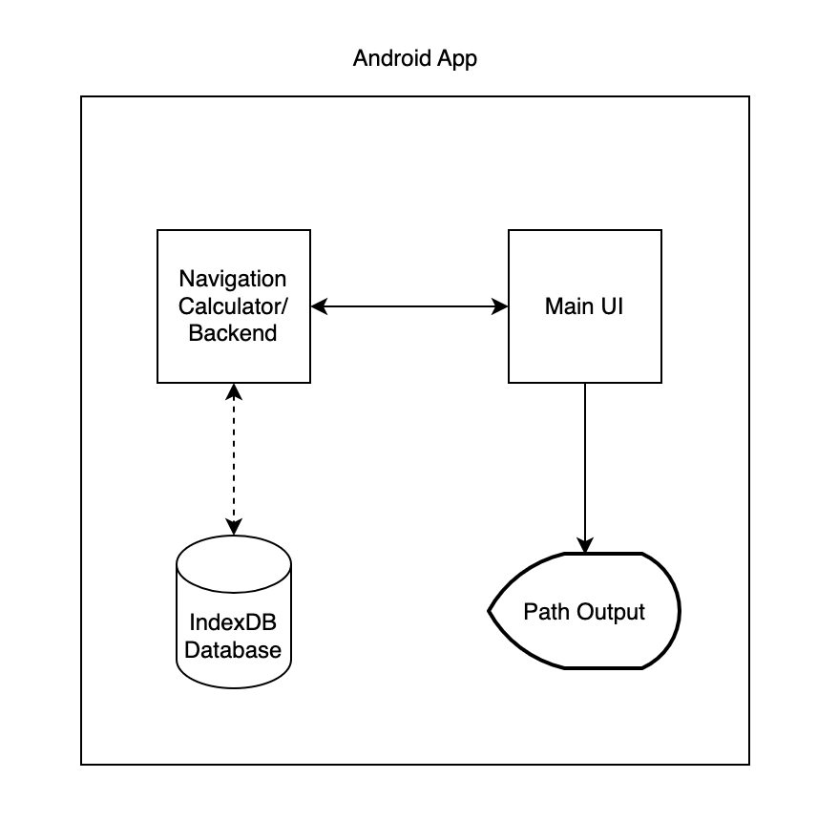

Flowchart:

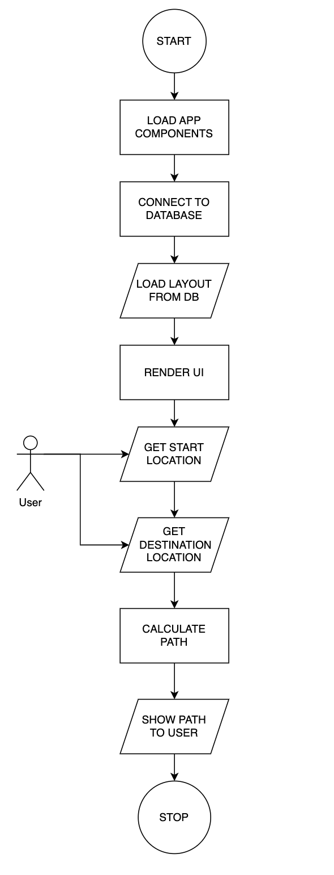

Flask



Star53,671
Flask is a lightweight WSGI web application framework. It is designed to make getting started quick and easy, with the ability to scale up to complex applications. It began as a simple wrapper around Werkzeug and Jinja and has become one of the most popular Python web application frameworks.
Flask offers suggestions, but doesn't enforce any dependencies or project layout. It is up to the developer to choose the tools and libraries they want to use. There are many extensions provided by the community that make adding new functionality easy.
from flask import Flask, escape, request

app = Flask(__name__)

@app.route('/')
def hello():
name = request.args.get("name", "World")
return f'Hello, {escape(name)}!'
$ env FLASK_APP=hello.py flask run
* Serving Flask app "hello"
* Running on http://127.0.0.1:5000/ (Press CTRL+C to quit)
Flask is a micro web framework written in Python. It is classified as a microframework because it does not require particular tools or libraries. It has no database abstraction layer, form validation, or any other components where pre-existing third-party libraries provide common functions. However, Flask supports extensions that can add application features as if they were implemented in Flask itself. Extensions exist for object-relational mappers, form validation, upload handling, various open authentication technologies and several common framework related tools.

Applications that use the Flask framework include Pinterest and LinkedIn.

Progressive Web Apps (PWAs)

Progressive Web Apps (PWAs) are a type of web application that leverages modern web technologies to provide a more app-like experience to users, even when accessed through a web browser on a mobile device like Web. PWAs aim to combine the best aspects of both web and native mobile apps, offering a seamless and engaging user experience.

Advantages of PWA Web Apps:

1. Cross-Platform Compatibility: PWA Web apps are built using web technologies such as HTML, CSS, and JavaScript. This means they can run on any platform with a modern web browser, including Web, iOS, and desktop systems, without the need to create separate codebases for each platform.

2. App-Like Experience: PWAs offer a responsive and smooth user experience similar to native mobile apps. They can be launched from the home screen, have smooth animations, and provide offline access to some extent.

3. Lower Development and Maintenance Costs: Developing a single PWA can potentially save development effort compared to building separate native apps for different platforms. This is because the same codebase can be used across platforms.

4. Automatic Updates: PWAs are updated automatically as they are accessed through the web. This ensures that users always have the latest version without needing to go through app store updates.

5. Improved Discoverability: PWAs are discoverable through web searches and links, making them more accessible to users without the need to download them from an app store.

6. Offline Access: PWAs can cache resources, enabling them to work partially or fully offline. This is particularly useful when users have limited or no internet connectivity.

7. Security: PWAs are served over HTTPS by default, ensuring a secure connection and protecting user data.

8. Engagement and Retention: PWAs can send push notifications, helping businesses engage users and increase retention rates, similar to native apps.

9. No App Store Restrictions: PWAs don't need to adhere to strict guidelines imposed by app stores, giving developers more flexibility in terms of content and features.

10. Faster Loading: PWAs are designed to load quickly, providing a seamless experience and reducing user frustration.

In conclusion, PWA Web apps offer a cost-effective and versatile solution for providing app-like experiences to users across different platforms. Their cross-platform compatibility, no-installation requirement, automatic updates, and other advantages make them an attractive option for businesses and developers looking to reach a wide audience without the complexities of maintaining separate native apps.

HTML5

HTML5 is a markup language used for structuring and presenting content on the World Wide Web. It is the fifth and last major HTML version that is a World Wide Web Consortium (W3C) recommendation. The current specification is known as the HTML Living Standard. It is maintained by a consortium of the major browser vendors (Apple, Google, Mozilla, and Microsoft), the Web Hypertext Application Technology Working Group (WHATWG).

HTML5 was first released in a public-facing form on 22 January 2008, with a major update and "W3C Recommendation" status in October 2014.[2][5] Its goals were to improve the language with support for the latest multimedia and other new features; to keep the language both easily readable by humans and consistently understood by computers and devices such as web browsers, parsers, etc., without XHTML's rigidity; and to remain backward-compatible with older software. HTML5 is intended to subsume not only HTML 4 but also XHTML 1 and DOM Level 2 HTML.

HTML5 includes detailed processing models to encourage more interoperable implementations; it extends, improves, and rationalizes the markup available for documents and introduces markup and application programming interfaces (APIs) for complex web applications. For the same reasons, HTML5 is also a candidate for cross-platform mobile applications because it includes features designed with low-powered devices in mind.

Many new syntactic features are included. To natively include and handle multimedia and graphical content, the new <video>, <audio> and <canvas> elements were added, and support for scalable vector graphics (SVG) content and MathML for mathematical formulas was also added. To enrich the semantic content of documents, new page structure elements such as <main>, <section>, <article>, <header>, <footer>, <aside>, <nav>, and <figure> are added. New attributes were introduced, some elements and attributes were removed, and others such as <a>, <cite>, and <menu> were changed, redefined, or standardized. The APIs and Document Object Model (DOM) are now fundamental parts of the HTML5 specification, and HTML5 also better defines the processing for any invalid documents.

CSS(Cascading Style Sheet)

CSS is used to control the style of a web document in a simple and easy way.
CSS is the acronym for "Cascading Style Sheet". This tutorial covers both the versions CSS1,CSS2 and CSS3, and gives a complete understanding of CSS, starting from its basics to advanced concepts.

Why to Learn CSS?
Cascading Style Sheets, fondly referred to as CSS, is a simple design language intended to simplify the process of making web pages presentable.
CSS is a MUST for students and working professionals to become a great Software Engineer specially when they are working in Web Development Domain. I will list down some of the key advantages of learning CSS:
- Create Stunning Web site - CSS handles the look and feel part of a web page. Using CSS, you can control the color of the text, the style of fonts, the spacing between paragraphs, how columns are sized and laid out, what background images or colors are used, layout designs,variations in display for different devices and screen sizes as well as a variety of other effects.
- Become a web designer - If you want to start a carrer as a professional web designer, HTML and CSS designing is a must skill.
- Control web - CSS is easy to learn and understand but it provides powerful control over the presentation of an HTML document. Most commonly, CSS is combined with the markup languages HTML or XHTML.
- Learn other languages - Once you understands the basic of HTML and CSS then other related technologies like javascript, php, or angular are become easier to understand.

Hello World using CSS.
Just to give you a little excitement about CSS, I'm going to give you a small conventional CSS Hello World program, You can try it using Demo link.
<!DOCTYPE html>
<html>
<head>
<title>This is document title</title>
<style>
h1 {
color: #36CFFF;
}
</style>
</head>
<body>
<h1>Hello World!</h1>
</body>
</html>

Applications of CSS
As mentioned before, CSS is one of the most widely used style language over the web. I'm going to list few of them here:
- CSS saves time - You can write CSS once and then reuse same sheet in multiple HTML pages. You can define a style for each HTML element and apply it to as many Web pages as you want.
- Pages load faster - If you are using CSS, you do not need to write HTML tag attributes every time. Just write one CSS rule of a tag and apply it to all the occurrences of that tag. So less code means faster download times.
- Easy maintenance - To make a global change, simply change the style, and all elements in all the web pages will be updated automatically.
- Superior styles to HTML - CSS has a much wider array of attributes than HTML, so you can give a far better look to your HTML page in comparison to HTML attributes.
- Multiple Device Compatibility - Style sheets allow content to be optimized for more than one type of device. By using the same HTML document, different versions of a website can be presented for handheld devices such as PDAs and cell phones or for printing.
- Global web standards - Now HTML attributes are being deprecated and it is being recommended to use CSS. So its a good idea to start using CSS in all the HTML pages to make them compatible to future browsers.

Prerequisites
You should be familiar with:
- Basic word processing using any text editor.
- How to create directories and files.
- How to navigate through different directories.
- Internet browsing using popular browsers like Internet Explorer or Firefox.
- Developing simple Web Pages using HTML or XHTML.

Database Used
IndexDB

IndexedDB (Indexed Database) is a low-level database API provided by modern webkit and PWAs to allow applications to store and manage structured data locally. It's designed for handling large amounts of data and provides a way for applications to create, read, update, and delete data in a structured manner. IndexedDB is particularly useful for building offline-capable applications, caching data, and improving performance by reducing server requests.

Here are the key features and concepts of IndexedDB:

1. NoSQL Database: IndexedDB is a NoSQL database, which means it doesn't follow the traditional table-based relational database model. Instead, it stores data in key-value pairs and provides an object store concept for organizing data.

2. Structured Data: Data in IndexedDB is structured using object stores, which can contain multiple objects (similar to records or documents in other databases). Each object can have properties and values.

3. Asynchronous: IndexedDB operations are asynchronous to avoid blocking the main thread of the browser, which ensures that the user interface remains responsive during database operations.

4. Versioning: IndexedDB supports versioning of databases and object stores. This allows developers to manage schema changes and data migration as their web application evolves.

5. Browsers and Security: IndexedDB is available in most modern web browsers, including Chrome, Firefox, Edge, and Safari. It operates within the browser's sandboxed environment to maintain security and data isolation.

6. Data Storage: IndexedDB can store various types of data, including strings, numbers, dates, arrays, and even structured objects like JSON. It provides different types of indexes for efficient data retrieval.

7. Transactions: Data manipulation in IndexedDB is performed within transactions. Transactions ensure data consistency and help manage multiple operations as a single unit.

8. Cursors: Cursors in IndexedDB allow you to iterate through the data in object stores. This is particularly useful for performing complex queries and retrieving data in specific orders.

9. Events: IndexedDB provides event listeners for tracking changes in the database, such as when data is added, updated, or deleted. This allows web applications to respond to data changes in real-time.

10. Quotas: IndexedDB operates within a quota system, where web applications are allocated a certain amount of storage space (quota) for their databases. This helps prevent abuse of local storage resources.

IndexedDB is commonly used for various purposes, including:

- Offline Web Applications: IndexedDB allows web applications to work offline by storing necessary data locally. This is useful for ensuring a seamless user experience even when the internet connection is lost.

- Caching: Web applications can use IndexedDB to cache frequently used data, reducing the need to fetch data from the server repeatedly.

- Progressive Web Apps: IndexedDB is often used in building progressive web apps (PWAs) that offer offline capabilities, allowing users to access the app even when they're not connected to the internet.

- Complex Data: For applications that deal with complex data structures, IndexedDB provides a more flexible solution compared to simple key-value storage systems like Web Storage (localStorage and sessionStorage).

However, it's important to note that working with IndexedDB can be more complex than using simpler storage mechanisms like cookies or Web Storage. It requires understanding asynchronous programming, handling transactions, and managing versioning. Many developers opt to use libraries and wrappers to simplify the process of working with IndexedDB.

Output Screenshot

